Want to earn a Starbucks gift card???

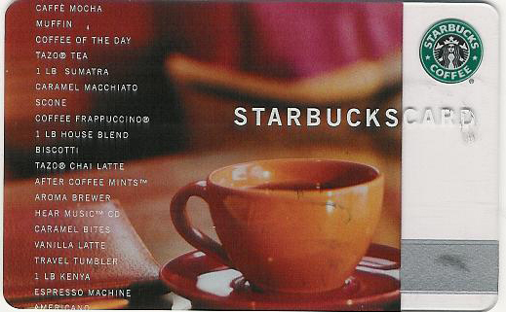

Who: College students or degree holders
What: Describe 3 pictures to a graduate clinician on video (~15 minutes)
When: Appts available Mondays 3-5
Why: Everyone needs coffee

Special Requirements: Monolingual English speakers only

Contact Dr. Celeste Domsch at 245-6578 or cd23@txstate.edu to schedule an appointment or for more information.

